Your

LOGO

here

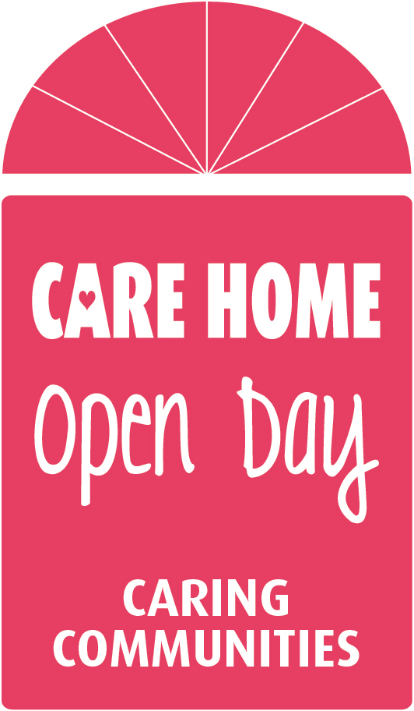 **Come and visit our home!**

**[CARE HOME NAME] is home to XX residents. We are proud of our home and proud of our community. We would like to invite you to come and spend some time with us, meet our residents and staff and discover what our home is all about!**

**On the 26th June come and enjoy:**

**(insert list of activities you will be hosting)**

* **xxxxx**
* **xxxxx**
* **xxxxx**
* **xxxxx**
* **and a chance to meet our residents and staff and hear their stories**

**We will be open for visitors from [insert time] and will finish the day with [insert your last activity or say coffee/tea & cakes] at [insert time].**

**All ages welcome, so come and enjoy the day!**

***We are a part of your community…***

***…and we want you to be a part of ours!***

**Find us at: [insert full address here]**

**Find out what’s happening by following Care Home Open Day on Twitter @CareHomeOpenDay , #CHOD2020**