Making Safeguarding Personal for Commissioners and Providers of Health and Social Care

London, 26 March 2019 | Birmingham, 25 April 2019

The workshop will focus on effective safeguarding for commissioners and providers of health and social care. We shall consider how we can move forward, keeping the Making Safeguarding Personal agenda at the heart of this.
The workshops will refer throughout to the LGA / ADASS resource for commissioners and providers on Making Safeguarding Personal (MSP).
The purpose of the workshops will be to influence practice, drawing on the essential steps set out in this resource for Making Safeguarding Personal. We will draw out what good should look like from the perspective of providers, commissioners, operational and strategic managers and regulators in health and social care and the barriers and enablers to achieving this.
It is intended that discussion and group work at the workshops will generate some core messages for commissioners and providers in taking forward effective safeguarding. These will be written up for sharing more widely.
Speakers are from the following perspectives:
There will be speakers from Department of Health and Social Care, National Institute for Health and Care Excellence, Care Quality Commission, NHS England, Commissioners and Providers of Health and Social Care, and the National Network of Independent Chairs of Safeguarding Adults Boards.
The presentations will focus on standards of good practice and learning from Safeguarding Adult Reviews.
Facilitators:
The day will be facilitated by Professor Michael Preston-Shoot and Jane Lawson.
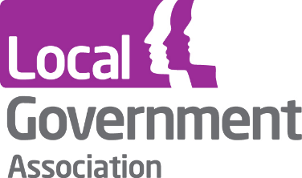
Professor Michael Preston-Shoot is Independent Chair of Brent Safeguarding Adults Board and Lewisham Safeguarding Adults Board. He chairs the London regional network of Independent Chairs. As an adult safeguarding consultant, he writes and researches safeguarding adult reviews, specialising in cases of self-neglect.
Jane Lawson works two days per week as Adviser in the Care and Health Improvement Programme Team based with the LGA. Supporting development of Making Safeguarding Personal is a key focus in this role. Jane has been involved in the national Making Safeguarding Personal programme since 2013.

Who should attend?
Those who are directly involved in or have an interest in commissioning and provision of health and social care. As well as those directly involved, this will include: strategic leads in health and social care, including safeguarding adults leads and independent Chairs of Safeguarding Adults Boards; Healthwatch, and organisations of / or representing service users and carers.
Registration
To register your interest in attending either event please email your name, job title and preferred workshop location to caroline.taylor@local.gov.uk by 8 February.
We will contact you by email, by the 14 February 2019 to confirm whether you have been allocated a place on the event or not. If successful you will then receive a link to the event booking website to formally book yourself a place.
Places will be limited so please apply promptly.
Please do not book transport until you have your place confirmed.

