Data Advisory Group 25.05.01 – Not for wider circulation
Agenda:
- 15:30 Hello and Welcome - Deanna Westwood
- 15:35 Update on long term provider data collection - plans Laura Bates
- 15:55 Feedback following the publication of data - Claire Beaton
- 16:10 Staff vaccination data query - Claire Beaton/Jason Snowdon
- 16:20 Workshops update - Nic Duffy / Scott Rutter
- 16:30 AOB
Update on long term provider data collection
Information provided by DHSC. This is a follow up to previous discussions on the future of data collection and Capacity Tracker. DHSC, have said that this isn’t as developed as they had hoped and therefore the information below is far from final.
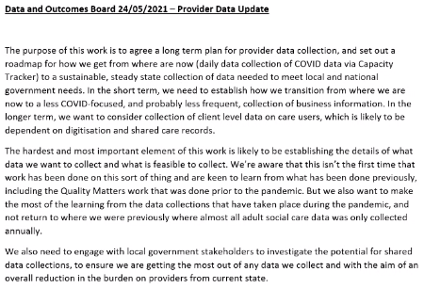
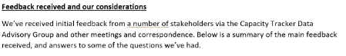
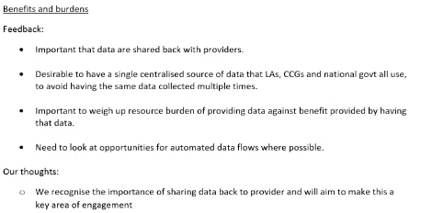
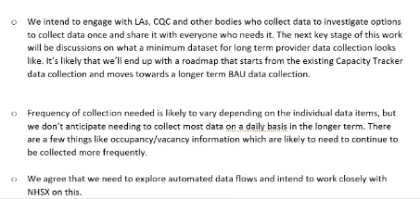
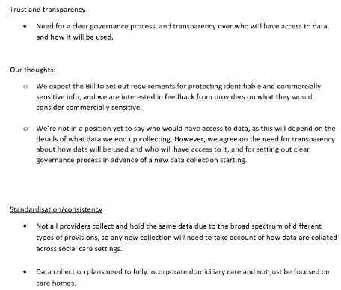
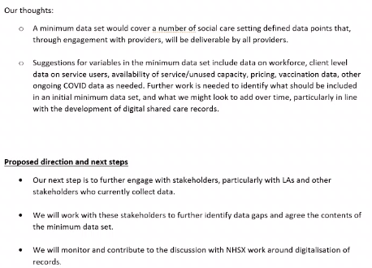
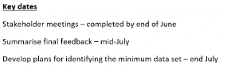
Feedback from group
- There needs to be clarity over what data is needed to be collected and why. Providers need to be properly informed over how ‘X’ data will benefit them.
- DHSC need to be clear about what data they want to collect. This will enable a discussion and negotiation period between providers and DHSC over what minimum data needs to be collected.
- Compromise will be key.
- DHSC need to be clear on how they will engage with all stakeholders.
- The Data Advisory Group will be used to advise this process. Skills for Care want to be involved and shall attend DAG meetings when necessary.

Feedback following the publication of data
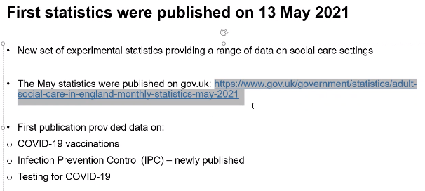
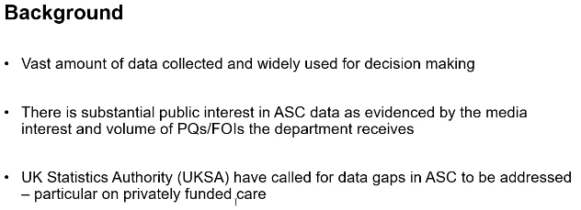
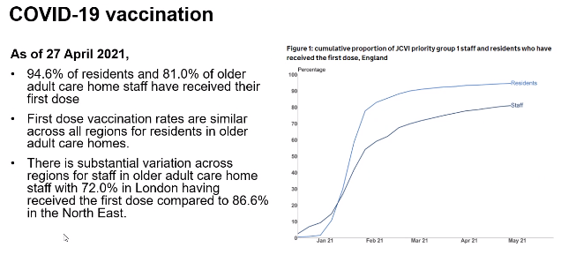
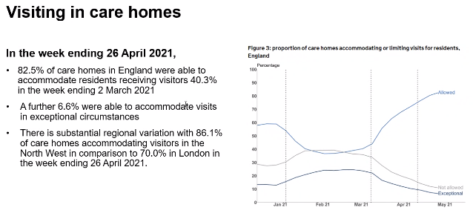
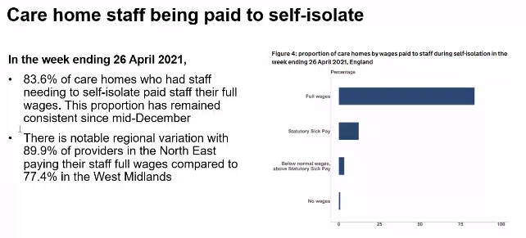
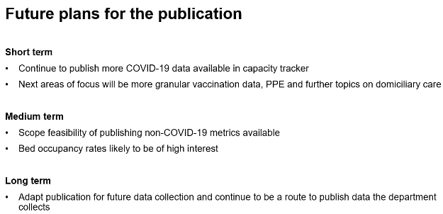
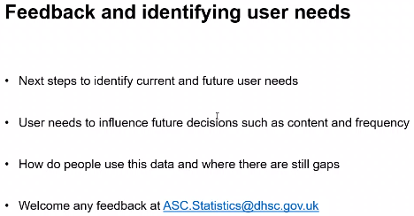
Feedback from the group
- Criticism over the lack of narrative, although the group understands that the Government has to publish these statistics.
- Concerns over the political decisions and the misinterpretations regarding staff being paid their full wage while self-isolating.
- The group stated that the publication of this data could lead to providers no longer providing the data. The data being published isn’t Government data, it is provider data.
- Going forward, especially with the intention of future data collection, the Government need to be clear that provider data will be getting published and therefore publicly available. Although specific provider data not get published, local, regional and national data will get published and providers need to know this. The group requested that future data collection comes with a consultation period so that providers can properly engage with DHSC.

Staff vaccination data query
DHSC is looking to publish a breakdown of staff vaccination data. Currently, public figures give an overall number/percentage. DHSC would like to break this down, as it is shown in the Capacity Tracker (Nurses, Care Staff, Non-Care Staff, Agency/Bank). This data will most likely get published in June’s publication (10.06.21). DHSC would like to know whether providers are concerned about the data getting published and would like feedback. Please email ASC.Statistics@dhsc.gov.uk by the end of the week (28.05.21).
Workshops update
DHSC thanked everyone who has been attending the workshops. It was stated that they have been useful and that there will be future ones on areas such as PPE.

AOB
Query over whether the CT data is being used to identify where the Indian variant is spreading. DHSC stated that while the breakout/testing data isn’t being used to identify where the Indian variant is spreading, the vaccination rate data is being used to help monitor the spread.

